Standard operating procedure: Requests to review provider selection decisions by the Independent Patient Choice and Procurement Panel (the Panel)

Content
  - Introduction
  - Request for review
  - Case management
  - Eligibility, acceptance and prioritisation
  - Panel advice
  - Appendix 1: Panel process

Note that the choice provider qualification complaints process is set out here [insert link].

Introduction
- This document sets out how the Panel may give advice where a provider requests a review of a relevant authority’s provider selection decision. The panel will give advice to the relevant authority on whether the relevant authority has followed the Health Care Services (Provider Selection Regime) Regulations 2023 (the PSR Regulations).
- A provider can request that the Panel review a provider selection decision made under the PSR by a relevant authority following direct award process C, the most suitable provider process, or the competitive process.
- The provider must first have made representations to the relevant authority and received the relevant authority’s further decision before a request can be made to the Panel.
- Where a provider is dissatisfied with the relevant authority’s decision, a review by the Panel is intended to be a suitable next step. Where a request is accepted the Panel will deliver its advice within a relatively short timeframe (see below).
- The Panel will not review provider selection decisions following direct award processes A or B, contract modifications or the urgent award process. The absence of a standstill period for contract award decisions under these provider selection processes means that the relevant authority can be expected to have put a contract in place with the provider selected by the relevant authority before any advice can be offered by the Panel. Moreover, to the extent that issues arise under direct award process B, the Panel believes that these are most likely to be addressable under patient choice rules.

Request for review
- If a provider wishes to request the Panel to consider their representations further, then they must submit their request through the appropriate pro forma within five working days of receiving the relevant authority’s decision following the relevant authority’s review of their representations.
- The provider must use the pro forma to confirm eligibility, provide information about the request (linked to the relevant PSR regulations) and supply the documentation requested by the Panel (i.e. the initial representations made to the relevant authority and the decision of the relevant authority).
- Any representations to the Panel by a provider should, unless there is good reason, only address matters that have previously been raised with the relevant authority.
- The relevant authority should keep the standstill period open for the duration of the Panel’s review.
- Providers and Relevant Authorities may employ legal representation when submitting representations to and engaging with the Panel. However, it is not a requirement.

Eligibility, acceptance and prioritisation
- The Panel has limited resources and has set out published acceptance criteria to determine whether a request will be reviewed.
- If a request is not accepted for review, the Panel will inform the provider and the relevant authority. The relevant authority can then close the standstill period as set out in the PSR statutory guidance and award the contract as intended before the request for review was made.

Panel review and advice
- Where the Panel accepts a representation for review it will write to the provider and relevant authority to confirm the review and to set out an indicative timetable. The panel will endeavour to provide its advice within 25 working days and will set out a timetable when a case is accepted.
- A case review panel will be appointed by the Chair to carry out the review. The provider and the relevant authority may be asked to provide additional information to support the review and may be asked to meet with the Panel to discuss the case. Any meetings or correspondence after the initial submission will be used to explore the issues raised in the initial submission and will not provide an opportunity to raise new matters with the case review panel. By submitting a representation to the Panel, providers should confirm they are available to attend a meeting within the Panel’s timetable.
- Where appropriate, the Chair may decide on a lighter touch review with a single member review panel and without the panel meeting with the parties to the case.
- The quality of the case panel’s advice relies partly on the engagement and timely responses of the provider and the relevant authority throughout the review process.
- At the end of the review the case review panel will issue its advice.
- Its advice may be that:
- the regulations were followed and therefore gives no advice to be taken;
- the regulations were not followed but the Panel considers the breach not to have had a material impact on the relevant authority’s selection of provider;
- the regulations were not followed, and the relevant authority is advised to return to an earlier step in the process to rectify the issue(s) identified; or
- the regulations were not followed, and the relevant authority is advised to abandon the current provider selection process.
- The Panel will publish its advice, or a summary of its advice, for completed reviews. The Panel may also make observations aimed at assisting relevant authorities in future provider selection processes.
- Once the relevant authority has considered the advice of the Panel, it may make a further decision, to be its final decision, replacing the previous one, to either:
- enter into a contract or conclude the framework agreement as intended
- go back to the start of the selection process or to the step where a flaw was identified, and repeat that step and subsequent steps, or
- abandon the selection process.
- See the PSR statutory guidance for further information. The Panel secretariat can be contacted at england.procurementpanelinfo@nhs.net.

Appendix 1: Panel process
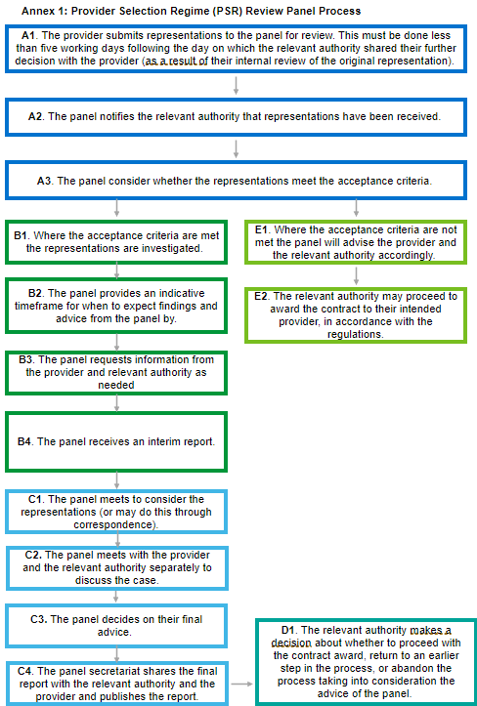

The published acceptance criteria also includes prioritisation criteria.

