Book your measles, mumps and rubella vaccines

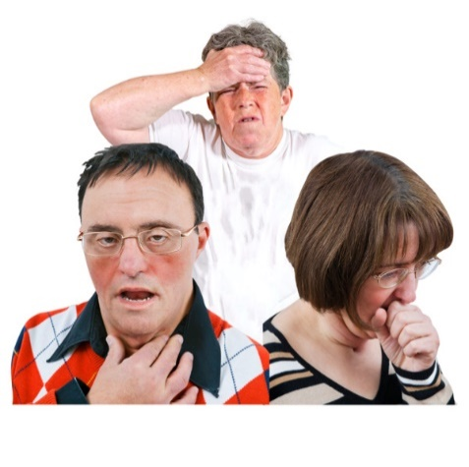 | Measles, mumps and rubella are infections that can spread easily between people. They can spread through coughs and sneezes.
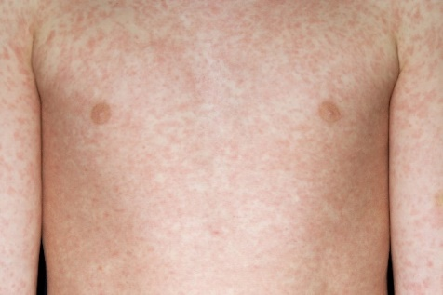 | More people in England are getting measles.  It can make you feel ill and give you a rash.
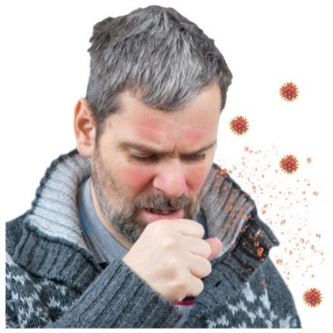 | For some people measles, mumps and rubella can lead to serious health problems. It’s important you get protected.
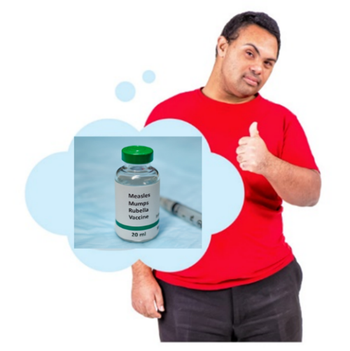 | You can have an injection called a vaccination to protect you from measles, mumps and rubella. It is called the MMR vaccine.
How to book your MMR vaccines
 | The information on your health record shows that you might not have had your MMR vaccines.
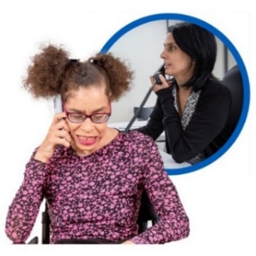 | Please contact your GP surgery or doctor to book an appointment for the MMR vaccine.
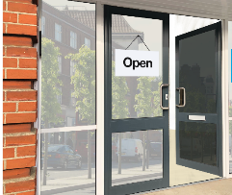  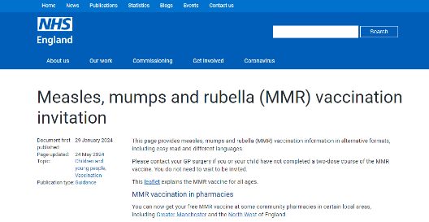 | Some pharmacies can now give MMR vaccines.  You can check if pharmacies in your local area are giving MMR vaccines at www.england.nhs.uk/mmr-invites  You may need support to read it.
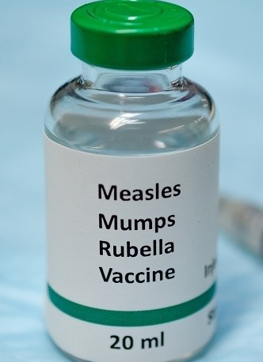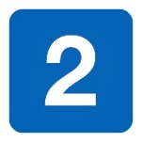 | You need 2 doses of the MMR vaccine for the best protection.  You will get them at 2 different appointments.
You can ask if you need any other vaccines.
If you do, you may be able to have these at the same appointment.

What happens at your appointment
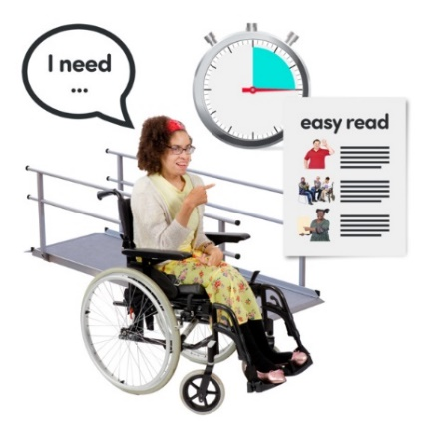 | You can ask your GP surgery to do things to make your appointment easier for you. This is called a reasonable adjustment.
 | If you don’t like needles or are worried about having an injection, you can take someone with you for support.
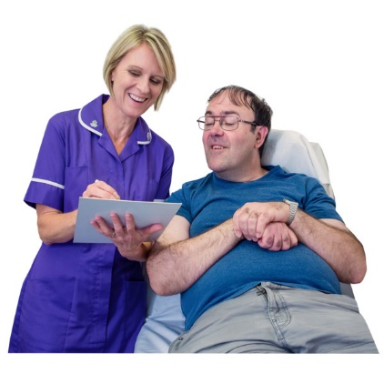 | At your appointment the doctor or a nurse will talk to you about the vaccine. They will make sure you are happy to have it.
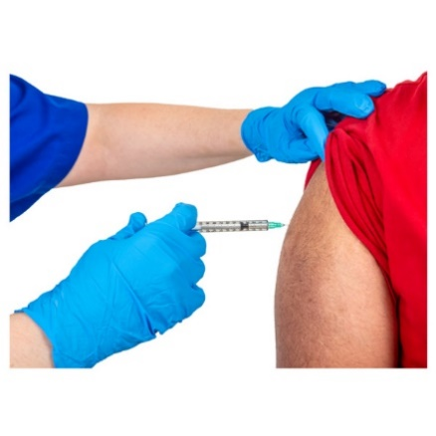 | The vaccine is an injection in your arm that will be given by the doctor or nurse.

What happens after your appointment
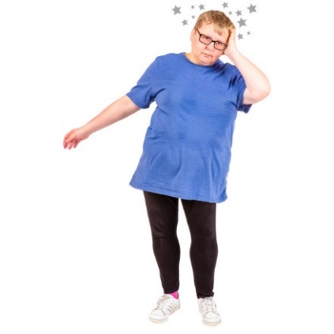 | Some people might feel a bit different after the vaccine. This is called a side effect.  The person who gives you the vaccine will talk to you about side effects and what to do.
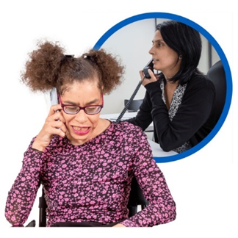 | If you feel very unwell after your vaccination or if you are worried you can contact your doctor.
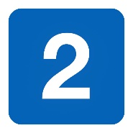 | If you need a second dose, the doctor or nurse will tell you to book another appointment.

More information
The vaccine is the best way to protect you from measles, mumps and rubella.

Lots and lots of people have the vaccine every year.

You can find more information about the vaccine online.
Go to www.nhs.uk/mmr
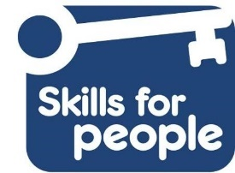
Easy read made by the Easy Info Team at Skills for People employing people with a learning disability.

